Optimized Routing for Cost Efficient Expansion

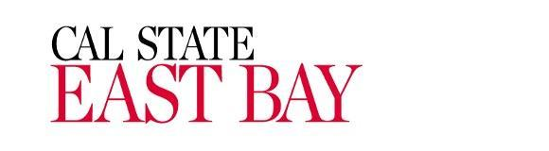

ENGR 693A: Applied Research in Engineering Management
Spring 2024 Semester

Submitted to: Dr. Farnaz Ganjeizadeh

Team Members: Aishwarya Radhakriashnan
Ana Osorio
Vishal Pandya
Table of Contents
List of Figures
List of Tables

Abstract - Ash: Done
1.Introduction - Ash: Done: need references
1.1 Objectives - Ana: Done
2.Literature Review - Vishal: Done: references are mentioned
3.Methodology- Connection-Vishal: Done
3.1 Problem Statement - Ana: Done
3.2 Mathematical modeling - Ana: Done: reference added
3.3 VRP Excel spreadsheet solver - Aish : Done:need reference
3.4 Tableau- Vishal: Done: need reference, NO REFERENCE NEEDED
3.5 In a nutshell
4. Analysis
4.1 Defining Variables- Ana
4.2 Cost Analysis - Ana done with references
4.3 Constraints Analysis - Ash
4.4 Defining the objective Function -Ana done
4.5 Solver Analysis- Ash : figures-done- Ana-can u please check: Checked
4.6 Mapping- Vishal: figures: Done
5. Conclusion -Vishal. Done. Ana: Checked
6. Future Work: Vishal. Done. Ana: Checked
7. References- Ash
8. Appendices

List of Tables

SL.No | Table | Page No
1. | Literature Review Table
2. | Results and Discussion

List of Figures

SL.No | Figures | Page No

Abstract:
In this comprehensive study, an advanced ExcelVRP solver is employed to optimize the distribution routes for Baskin Robbins ice-cream to five suburban outlets, aiming to identify the most cost-effective pathways by considering a multitude of logistical constraints, including vehicle capacity, optimal delivery timings to mitigate traffic impact, and precise distances and unloading times at each retail location. The solver's adept application facilitates a significant reduction in operational costs, bringing it down to a notable $1004.98, by efficiently navigating through the complex logistics, thereby ensuring that each store is serviced at least once within the delivery schedule. The research further delves into the solver's ability to streamline intricate delivery schedules into an easily manageable model, offering a deep dive into the impact of various routing parameters on overall efficiency and cost. Additionally, the study probes into the model's scalability and adaptability for potential application across broader geographic locales within the Bay Area, highlighting its strategic value in facilitating cost-efficient operational expansions. This investigation not only showcases tangible operational savings but also sets a precedent for utilizing advanced logistical tools in enhancing distribution efficiency and readiness for strategic growth in the competitive consumer goods sector.

1.Introduction
In the intricate landscape of retail distribution, the strategic optimization of delivery routes is a critical factor in enhancing operational efficiency and reducing costs. For a globally recognized brand like Baskin Robbins, renowned for its vast array of ice-cream products, the challenge intensifies in suburban areas where logistical variables such as traffic patterns, delivery time windows, and store locations add layers of complexity. Traditional routing methods often fall short in addressing these multifaceted challenges, necessitating the adoption of advanced computational tools to navigate this dynamic environment effectively.

Enter the realm of the ExcelVRP solver, a sophisticated tool designed to tackle the Vehicle Routing Problem (VRP), a cornerstone issue in logistics and supply chain management. The VRP focuses on determining the most efficient routes for a fleet of vehicles to deliver goods to various locations, factoring in constraints like vehicle load capacity and delivery deadlines. In this context, the ExcelVRP solver emerges as a pivotal asset, capable of assimilating and analyzing extensive logistical data to craft optimized delivery pathways that promise significant reductions in operational costs.

This study delves into the application of the ExcelVRP solver to streamline the delivery routes for five Baskin Robbins outlets situated in suburban settings. By meticulously processing inputs such as vehicle capacities, strategic delivery timings to elude peak traffic, and precise distances between the central warehouse and retail outlets, the solver endeavors to minimize the total logistical expenditure. The investigation extends beyond mere cost analysis, exploring the solver's potential in enhancing service reliability and time efficiency, thereby contributing to an elevated customer experience.

Moreover, the research does not confine itself to operational optimization; it ventures into assessing the scalability of the proposed model. This aspect is crucial, considering the ever-expanding footprint of Baskin Robbins and similar retail giants, highlighting the ExcelVRP solver's adaptability and its role in supporting strategic business expansion. Through a blend of mathematical rigor and practical application, this study aims to set a new benchmark in the optimization of retail distribution networks, offering insights that transcend the immediate scope of ice-cream delivery to encompass broader logistical applications.

1.1 Objectives

Objective 1: Develop algorithms to minimize delivery time and cost by efficiently routing Baskin Robbins ice cream trucks to multiple destinations while considering factors such as demand, vehicle capacities, and time windows for delivery.

Objective 2: Analyze and suggest, based on the time consumption of the current model, the addition of new locations in the route to maximize the utilization of the resources for delivery and minimize the cost of distribution of Baskin Robbins ice cream chain.

2.Literature Review

Literature research is conducted to provide a background for this study. Vehicle routing problem is among the most commonly researched topics in the area of supply chain. Varying conceptualizations of VRP can be observed in extant literature. A summary of the literature review, topic, method, strength and weaknesses of these sources used for this study is given in Table 1.

Reference | Topic | Method | Strength | Weakness
Dávila et al. (2021) | Vehicle Routing Problem with Deadline and Stochastic Service Times: Case of the Ice Cream Industry in Santiago City of Chile. | Tabu Search and Chaotic Search with Monte Carlo simulations | Effective in dealing with stochastic service times and optimizing routes, leading to cost savings and efficiency in delivery. | Longer resolution times, reduced maximum customer capacity, increased demands for distances and vehicles
Puspitasari et al. (2020) | Modeling the best route and truck capacity for delivering ice cream product | Vehicle Routing Problem, ECOST Method. | Optimizes truck capacity and routes for cost reduction, considering unique ice cream temperature requirements. | Solving the VRP model, particularly for large-scale distribution networks, can be computationally intensive and time-consuming.
Zhang & Chen (2014) | An Optimization Model for the Ve  vehicle Routing Problem in Multi-  product Frozen Food Delivery | Genetic Algorithm Heuristic | Optimizes frozen food delivery for cost-efficiency while maintaining freshness and safety. | The study doesn’t include complex assumptions, so there are real world factor that is not considered in the optimization model
Qin et al. (2019) | A Vehicle Routing Optimization Problem for Cold Chain Logistics Considering Customer Satisfaction and Carbon Emissions. | Cycle Evolutionary Genetic Algorithm (CEGA) | High cost-effectiveness and scientific validity, achieving 70% customer satisfaction with minimal cost increases | No customer satisfaction factor are included in the algorithm

Several studies indicate that while some specific JIT practices may improve certain performance dimensions, they may not improve all performance dimensions.

For example, Dávila et al. (2021) found that VRP is significantly associated with cost, delivery and cycle time performance but not with quality performance. Puspitasari et al. (2020) found solving VRP for expansive networks can be intensive. Zhang & Chen (2014) failed to include complex assumptions, so there are real world factors that are not considered in the optimization model.

Among recent studies, there is no evidence of a comparison done in the ice-cream industry. And this project is based on demonstrating the Vehicle Routing Problem for the Ice-cream industry for case companies as Baskin and Robbins. This study highlights the VRP practices that have the greatest impact on critical parameters as constraints and aids to offer the shortest path. In the next chapter general concepts of the VRP model are presented.

Vehicle routing problem and related algorithms for logistics
distribution: a literature review and classification

Overview:
The research indicates that the development and application of hybrid algorithms have become increasingly significant, reflecting the ongoing efforts to optimize real-life distribution cases through the integration of advanced algorithmic approaches. This trend underscores the importance of hybrid algorithms in addressing the complexities of logistics distribution and reflects the research community's recognition of the potential benefits of integrating multiple algorithmic approaches to solve VRP variants effectively.

Disadvantages:
The research primarily emphasizes the most prevalent VRP variants, such as the Capacitated VRP and the VRP with Time Windows, potentially overlooking less studied variants, such as the Truck and Trailer Routing Problem (TTRP). The paper's exclusion of certain terms and topics, such as "waste," "healthcare," and "location routing," may limit the scope of the research, potentially overlooking valuable insights from related fields that could contribute to a more comprehensive understanding of logistics distribution challenges.

Vehicle Routing Problem with Deadline and Stochastic Service Times: Case of the Ice Cream Industry in Santiago City of Chile. By Dávila, S., Alfaro, M., Fuertes, G., Vargas, M., & Camargo, M. (2021). Mathematics, 9(21), 2750.

Overview:
The document presents the outcome and advantages of using metaheuristic algorithms, specifically tabu search (TS) and chaotic search (CS), to solve the Vehicle Routing Problem with Deadline and Stochastic Service Times (VRPTW-ST) in the context of the ice cream industry in Santiago, Chile. The study demonstrates that the CS algorithm obtained better results compared with TS, showing the effectiveness of incorporating chaotic neurons when choosing candidates. The results obtained with TS and CS algorithms for the ice cream industry problem show a clear decrease in processing time, reduction in the distance traveled, compliance with deadlines, and avoidance of generating extra work.

Disadvantages:
The document does not explicitly discuss the potential environmental impact of the distribution operations, such as fuel consumption, emissions, or sustainability considerations. Additionally, it does not delve into the potential social or economic implications of the optimized distribution routes on the local community or the workforce involved in the ice cream industry.

An Optimization Model for the Vehicle Routing Problem in Multi-product Frozen Food Delivery
Y. Zhang * and X. D. Chen

The objective is to find the routes that represent the minimum delivery cost for a fleet of identical vehicles that depart from a depot, visiting all customers only once and returning to the depot. The delivery cost includes the transportation cost, the cost of refrigeration, the penalty cost and cargo damage cost based on the characteristics of different frozen food products.
Disadvantages:
One of the missed aspects in the research is the consideration of real-world complexities in cold chain distribution, such as the travel time of vehicles, service time for customers, different delivery requirements, fleet size, mixed-type vehicles, multi-temperature joint distribution, and vehicle routing problems with backhauls.

A Vehicle Routing Optimization Problem for Cold Chain Logistics considering Customer Satisfaction and Carbon Emissions Gaoyuan Qin, Fengming Tao * and Lixia Li

Summary:
The research in this document focuses on optimizing cold chain logistics distribution networks by considering customer satisfaction and carbon emissions. However, it does not consider other factors such as the freshness of products, loss rates, and other real-life scenarios that could impact customer satisfaction.

Disadvantages:
The research does not address the potential disadvantages or limitations of the proposed model, such as the complexity of implementing the comprehensive VRP-CSC model in practical logistics operations, the potential trade-offs between cost, customer satisfaction, and carbon emissions, and the challenges of integrating the carbon trading mechanism into the optimization model.
Furthermore, the research does not discuss the potential risks or drawbacks of relying on the Cycle Evolutionary Genetic Algorithm (CEGA) for solving the optimization model, such as computational complexity, scalability, and the need for extensive computational resources.

3.Methodology
The mathematical modeling of routing problems, exemplified by the Vehicle Routing Problem (VRP), is foundational for algorithmic resolution in fields like transportation and logistics. Utilizing variables like N (number of locations), M (number of vehicles), and Q (vehicle capacity), the model aims to minimize total cost, integrating factors like distance and vehicle-related expenses. Constraints ensure each location is visited once by a vehicle, while adhering to vehicle capacity limits. The VRP Spreadsheet Solver, an advanced open-source tool, offers a comprehensive solution with its Excel-based interface and adaptable functionalities. The selection of this solver was driven by its versatility to make changes and additions to the existing VRP spreadsheet solver, user-friendliness, and customization potential, crucial for addressing complex logistics challenges effectively.

3.1 Problem Statement

The vehicle routing problem (VRP) presents a significant logistical challenge for ice cream chains aiming to deliver their products efficiently to various locations while maintaining product quality and minimizing operational costs. Despite all the tools available these days, and the advanced technology used to develop vehicle routing, there remains a gap regarding the application of the VRP in specific conditions and requirements that each product has.

This project aims to address this gap by developing and analyzing a VRP customized according to the needs that are present at the moment for Baskin Robbins ice cream chain. The primary objectives include optimizing delivery routes to minimize the cost that is generated by travel time and distance, ensuring the demand that each location requires weekly, the time windows that are permitted for these deliveries and the capacity of the trucks, including the costs associated with refrigeration. All constraints are real- world constraints suggested by Baskin Robbins Ice Cream shops.

By developing this mathematical model, this project intends to propose a practical and scalable solution that can be adopted for other locations and other ice cream chains.

3.2 Mathematical modeling

Mathematical modeling is a crucial aspect of solving routing problems, as it helps in formulating the problem in a way that can be addressed algorithmically. Routing problems are common in various fields, such as transportation, logistics, and networking.

A general framework for mathematical modeling of routing problems, focusing on a classic example known as the Vehicle Routing Problem (VRP):

$N: Number of locations N=\left\{1,2,3...\right\}$
$M: Number of vehicles M=\left\{1,2,3...\right\}$
$Q: Vehicle Capacity$
$d_{ij}= distance between location i and location j$
$q_{i}=Demand of customer i$

Decision variables:

$x_{ij}=Binary variable indicating whether there is a route from customer i to customer j$
1 if the route exists otherwise 0

Objective Function:
Minimize the total cost, which is often a combination of travel distance or time and vehicle-related costs. The objective function might look like:
Minimize $\sum_{i=1}^{n}{}\sum_{j=1}^{n}{}d_{ij}∙x_{ij}$ [4] (1)
The model also needs to include constraints that are regularly included in solving vehicle Routing Problems.
Constraints:
Each vehicle visits the location once
$\sum_{i=1}^{n}{}x_{ij}=1 for j=1,2,…...$ [4] (2)
$\sum_{j=1}^{n}{}x_{ij}=1 for i=1,2,......$ [4] (3)

Vehicle capacity
$\sum_{i=1}^{n}{}q_{i}∙x_{ij}≤Q for j=1,…,n$ [4] (4)

Binary variable
$x_{ij} ϵ \left\{0,1\right\} for i, j ϵ N$ [4] (5)
$u_{i} ϵ Z^{+} for i ϵ N$ [4] (6)
This is a simplified model, and variations may be needed depending on specific constraints and requirements. Solving techniques, such as integer programming, heuristics, or metaheuristics, can be applied to find optimal or near-optimal solutions to the routing problems described by these mathematical models. Toth and Vigo (2002, p. 12)

3.3 VRP Excel spreadsheet solver
The VRP Spreadsheet Solver is an Excel-based tool designed to solve various configurations of vehicle routing problems. Its intuitive interface and comprehensive functionality allowed us to model our routing scenario accurately, considering multiple logistical constraints and objectives.

Structure of the Solver: Our application of the VRP Spreadsheet Solver involved the following components, structured across different worksheets within the Excel workbook:
- VRP Solver Console: This initial worksheet served as the command center for our project, where we input general parameters such as the number of depots, customers, vehicle types, and the dimensions of time windows. It also allowed us to configure options for GIS data retrieval, essential for accurate distance and travel time calculations between locations.
- Locations: In this worksheet, we detailed our operational nodes, including their names, addresses, coordinates, and service requirements. The ability to import coordinates directly from a GIS web service ensured the precision of our location data, critical for the subsequent routing optimization.
- Distances: This critical component of the solver provided us with the distances and travel durations between all pairs of locations specified in the 'Locations' worksheet. Utilizing the GIS web service, we populated this worksheet with accurate, real-time data, accounting for various routing preferences such as shortest versus fastest routes.
- Vehicles: Here, we defined the specifications of our fleet, including the number of vehicles, their capacities, cost parameters, and operational limits. This worksheet allowed us to tailor the solver to our specific fleet characteristics, ensuring the generated solutions were practical and implementable.
- Solution: After setting up the initial parameters, location details, distances, and vehicle specifications, our methodology advanced to the analysis of routing solutions. The "Solution" worksheet synthesized the information from previous sheets to generate a list of optimized routes for each vehicle, taking into account the constraints and objectives defined earlier. This worksheet not only calculated the optimal routes but also provided insights into the net profit associated with each route, aligning with our project's goal to maximize efficiency while considering the financial impact. To ensure feasibility and adherence to operational constraints, the sheet utilized conditional formatting to highlight any potential issues, such as capacity exceedance or scheduling conflicts. This feature was instrumental in allowing us to quickly identify and rectify infeasible solutions, thereby streamlining the optimization process.

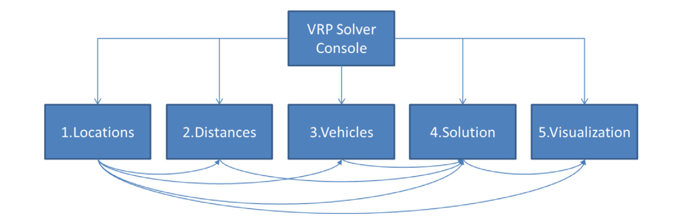
Fig. Spreadsheet structure of the VRP Spreadsheet Solver

Throughout our application of the VRP Spreadsheet Solver, we leveraged its detailed analytics to make informed decisions, maximizing route efficiency while weighing financial outcomes. The solver's adaptability and comprehensive analysis tools proved invaluable in refining our logistics strategy, though we noted areas for potential enhancement, particularly in processing speed for large datasets.

3.4 Navigational Mapping
We are using Tableau as a tool to provide the Vehicle Routing visualization. It is a powerful data visualization tool widely utilized across industries to transform complex datasets into insightful visual representations. With its intuitive interface and extensive array of features, Tableau enables users to explore, analyze, and communicate data effectively. Whether it's creating interactive dashboards, generating dynamic charts, or designing maps to showcase geographical data, Tableau offers versatility in visualizing information. Its drag-and-drop functionality allows for seamless integration of various data sources, empowering users to uncover patterns, trends, and correlations within their datasets. Moreover, Tableau's robust mapping capabilities enable users to plot geographic data accurately, providing a spatial context to their analyses. From business intelligence and analytics to data-driven decision-making, Tableau serves as a valuable tool for organizations seeking actionable insights from their data.
Here are some of the ways mapping in Tableau can be helpful:
Geospatial Analysis: Tableau allows users to analyze and visualize data in the context of geography. By mapping data points onto a map, users can identify patterns, trends, and correlations that may not be apparent in traditional tabular formats.

Spatial Relationships: Mapping in Tableau helps users understand spatial relationships between different data points. For example, users can visualize the distribution of customers, sales, or facilities across regions and identify areas of concentration or gaps.

Route Optimization: Tableau's mapping capabilities can be used to optimize routes for logistics, transportation, or field service operations. By visualizing routes on a map and analyzing factors such as distance, traffic, and stops, users can improve efficiency and reduce costs.

Location Intelligence: Mapping in Tableau enables users to gain location intelligence by integrating geographic data with other business data. This allows for deeper insights and informed decision-making, such as site selection, market analysis, and territory planning.

Interactive Visualization: Tableau's interactive mapping features allow users to explore data dynamically. Users can zoom in/out, pan across the map, filter data based on location, and drill down into specific regions or data points for further analysis.

Communication and Presentation: Maps created in Tableau are visually compelling and effective for communicating insights to stakeholders. Whether in reports, presentations, or dashboards, maps provide a clear and intuitive way to convey geographic information and analysis results.

Contextual Understanding: Mapping in Tableau provides context to data by visualizing it within its geographic context. This helps users understand the real-world implications of their data and make more informed decisions.

3.5 In a nutshell
Mathematical modeling serves as the foundational framework for addressing routing problems such as the Vehicle Routing Problem (VRP), which are pervasive across diverse domains like transportation, logistics, and networking. By employing mathematical modeling techniques, we plan to precisely formulate the problem, encapsulating various constraints and objectives, thereby paving the way for algorithmic solutions. VRP, involves determining optimal routes for a fleet of vehicles to serve a set of locations, minimizing costs or maximizing efficiency. Spreadsheet solvers dedicated to VRP, like the VRP spreadsheet solver, offer a user-friendly interface coupled with robust functionality. These tools enable the translation of mathematical models into practical solutions by allowing users to input parameters, constraints, and objectives, and obtaining optimal or near-optimal routing configurations. Additionally, navigational mapping tools like Tableau complement the modeling and solving process by providing intuitive visualizations of the vehicle routing. Tableau's versatility in data visualization allows for the creation of interactive dashboards, dynamic charts, and geographical maps, facilitating the exploration, analysis, and communication of routing data effectively. Through this integrated approach, mathematical modeling lays the groundwork, spreadsheet solvers generate solutions, and Tableau enhances understanding through visualization, collectively offering a comprehensive methodology for tackling the complexities of the Vehicle Routing Problem.

4. Analysis
4.1 Defining variables
To start building the Vehicle Routing Problem for Baskin Robbins, it is necessary to define the variables first.
The representation for these locations in the mathematical model would be $C_{ij}$ and the locations considered in this VRP are Redwood City 1 located in el Camino Real, Redwood city 2 located in Roosevelt shopping center, Menlo Park located in Santa Cruz Avenue, East Palo Alto located in Bayshore Road, Palo alto located in Middlefield Road and the Depot located in Manteca. All the locations are in the state of California.
The variable will have a binary value meaning going from one location to another in the optimal solution to find the shortest distance.
The distances between a location i to a location j will be represented by $X_{ij}$. These distances will develop an important role in getting the optimal solution to minimize the cost of the transportation of the Ice cream tubs and quartz for Baskin Robbins.

The exact location is defined in the table below:

Name | Address
Depot- Manteca | 730 Spreckels Ave. Manteca, Ca 95336
Palo Alto | 2615 Middlefield Rd, Palo Alto, CA 94306
East Palo Alto | 1765 E Bayshore Rd Ste. A2, East Palo Alto, CA 94303
Menlo Park | 863 Santa Cruz Ave, Menlo Park, CA 94025
Redwood City 1 | 1501 El Camino Real, Redwood City, CA 94063
Redwood City 2 | Roosevelt Shopping Center, 2107 Roosevelt Ave, Redwood City, CA 94061
Table #. Depot and Store Locations

Once the locations are defined, using the tools available like Google Maps, it is necessary to define the distance between locations to determine the optimal solution.
The distances represented by $X_{ij}$ are shown in the next table:

From | To | Distance in miles
Depot- Manteca | Palo Alto | 78.00
Depot- Manteca | East Palo Alto | 70.00
Depot- Manteca | Menlo Park | 74.00
Depot- Manteca | Redwood City 1 | 74.00
Depot- Manteca | Redwood City 2 | 75.00
Palo Alto | Depot- Manteca | 74.00
Palo Alto | East Palo Alto | 3.10
Palo Alto | Menlo Park | 4.20
Palo Alto | Redwood City 1 | 6.90
Palo Alto | Redwood City 2 | 8.00
East Palo Alto | Depot- Manteca | 70.00
East Palo Alto | Palo Alto | 3.40
East Palo Alto | Menlo Park | 4.10
East Palo Alto | Redwood City 1 | 6.30
East Palo Alto | Redwood City 2 | 7.40
Menlo Park | Depot- Manteca | 72.00
Menlo Park | Palo Alto | 4.00
Menlo Park | East Palo Alto | 4.00
Menlo Park | Redwood City 1 | 3.40
Menlo Park | Redwood City 2 | 4.50
Redwood City 1 | Depot- Manteca | 78.00
Redwood City 1 | Palo Alto | 9.90
Redwood City 1 | East Palo Alto | 10.00
Redwood City 1 | Menlo Park | 3.80
Redwood City 1 | Redwood City 2 | 1.70
Redwood City 2 | Depot- Manteca | 79.00
Redwood City 2 | Palo Alto | 10.00
Redwood City 2 | East Palo Alto | 10.00
Redwood City 2 | Menlo Park | 4.50
Redwood City 2 | Redwood City 1 | 1.50
Table #. Distances between locations

4.2 Cost Analysis
For this vehicle routing problem, there are three kinds of cost that are taken into consideration, a variable cost that would depend on the optimal route, another variable cost that would depend on the time spent in each location unloading the products and a fixed cost of transportation.

The first Variable cost is defined as the cost of gasoline consumption and the depreciation of different parts or material that are necessary for the correct functioning of the car like tires, oil, etc. For these costs, it was necessary to understand the kind of vehicle used to define the average gas consumption of the vehicle, the kind of tires and the amount of oil. The vehicle that is taken in consideration for this case is an approximate. The vehicle can change depending on availability.

The vehicle’s specifications used for this study is , Ice Cream refrigerated truck box model GET.6KDX.XIC. brand Get Industry, Trailerbull. (Ice Cream Refrigerated Truck Box - Buy Refrigeration Truck Body, Ice Cream Refrigerated Truck Box Product on Get Industry | Trailerbull | the Truck Camper and Trailer Company, n.d.)
All these costs are transferred in terms of miles giving as a result $0.75 per mile.

The second variable cost is defined by the cost of keeping the refrigeration working during the unloading time, since Baskin Robbins needs to keep the cold chain to make sure the quality of the ice cream products remains the same until the destination. For this the cost is taken as $0.45 per minute and it is calculated as an average cost according to the article Figuring cost per mile. (OOIDA, 2023)

Finally, the fixed cost is defined by the number of employees and external factors that affect the delivery operation for Baskin Robbins. This cost is equal to $797 per delivery trip. (OOIDA, 2023)

4.3 Constraint Analysis
This section focuses on the constraints that shape the solution space for the ExcelVRP solver, used in optimizing the distribution routes for Baskin Robbins ice-cream to five suburban outlets. Understanding these constraints is essential as they are instrumental in achieving an efficient, cost-effective distribution system while adhering to logistical limitations.

Equations will be written later.

- Demand Constraint (1): The total sum of distribution costs for each shop must be greater than or equal to 625, ensuring that the outlets' weekly demand is adequately met. This ensures service reliability and customer satisfaction.
- Capacity Constraint (2): The total distribution cost across all shops must also remain below 650 to align with the vehicle's capacity limits. This constraint prevents overloading the distribution vehicles, optimizing their use while preserving vehicle longevity.
- Service Constraint (3): A binary constraint ensures each location is visited at least once. This is a fundamental requirement for the distribution network to ensure that all stores receive their ice-cream stock.
- Routing Constraints (4, 5, 6): These constraints are critical in forming feasible routes. They require the route to start and end at the depot, with each vehicle's journey tracked to ensure that it does not disappear or spontaneously spawn at any location.
- Positivity Constraint (7): All variables, representing distances, times, and costs, must be non-negative. This standard constraint reflects real-world conditions where these variables cannot logically be negative.

Detailed Constraint Considerations
Demand and Capacity Harmony: Balancing the outlets' demand (Constraint 1) with vehicle capacities (Constraint 2) is key. This ensures deliveries meet needs without overloading vehicles, optimizing costs and safety.
Efficient Routing: Service (Constraint 3) and routing constraints (4, 5, 6) work together to minimize redundancies in travel, directly impacting fuel use and delivery efficiency.
Feasibility Checks: The non-negativity (Constraint 7) and vehicle continuity (Constraint 6) constraints are practical checks that keep proposed routes realistic and actionable.
Practical Context: These constraints consider the on-ground realities of delivery timings and unloading durations, ensuring the model's applicability to Baskin Robbins' daily operations.
In essence, the constraints are carefully chosen to reflect the operational intricacies of Baskin Robbins' distribution network, guiding the solver to find solutions that are not just cost-minimizing but also operationally sound.

4.4 Defining the Objective function.
After defining what is going to be consider in the optimal solution, from the cost to the limitations of this algorithm (constraints), the construction of the specific algorithm considered for Baskin Robbins model and considering a group of stores (five locations) defined by near neighborhoods is taken place as follow:
$\sum{}X_{1}+0.75{C_{ij}X}_{ij}+0.45{C_{ij}Y}_{i}$
Where:
$X_{1}=fixed cost per trip$
$C_{ij}= \left\{1, if vehicle travels from i to j location, 0 otherwise\right\}$
$x_{ij}=Distance from i location to j location$
$y_{i}=Unloading time in i location$
Then the constraints would be defined by:
$\sum{}96C_{1}+128.5C_{2}+149C_{3}+112C_{4}+139.5 C_{5}≥625$ (1)
$\sum{}96C_{1}+128.5C_{2}+149C_{3}+112C_{4}+139.5 C_{5}≤650$ (2)
$\sum{}C_{ijk}=1$ (3)
$\sum{}C_{i,n+1,k}=1$ (4)
$\sum{}C_{i,0,k}=1$ (5)
$\sum{}C_{ijk}-\sum{}C_{ijk}=0$ (6)
$C_{ijk}>0$ (7)

Being:
$C_{1}=Palo alto Store$
$C_{2}=East Palo alto Store$
$C_{3}=Menlo Park Store$
$C_{4}=Redwood City 1 Store$
$C_{5}=Redwood City 2 Store$
And each equation represent:
- Demand constraint, at least meet the weekly demand.
- Capacity constraint, not exceed the capacity of the truck.
- Each location needs to be visited once.
- Route ends in depot +1
- Route starts in depot 0
- The truck enters in i Location and departs i location.
- All variables need to be positive.
This objective function is defined according to the characteristics of this specific vehicle problem which includes the constraints necessary to keep the quality of the process and meet the needs of each store, looking for minimizing the cost of transportation and the time and effort put into it.

4.5 Solver Analysis
4.5.1. Location Sheet Analysis
The "1.Locations" sheet provides a detailed overview of the distribution points, including the depot in Manteca and various Baskin Robbins outlets across the area. Here are some key observations:
- Outlet Locations: The sheet lists outlets in Palo Alto, East Palo Alto, Menlo Park, and Redwood City, among others, each with specific coordinates to denote their geographical positions.
- Time Windows: Each location, including the outlets, has a defined time window from 00:00 to 06:00, indicating a narrow delivery window likely aimed at early morning deliveries to avoid traffic and ensure readiness for business hours.
- Service Requirements: The sheet notes "Must be visited" for all outlets, emphasizing the necessity of servicing each location within the delivery schedule. The depot is marked as the "Starting location," indicating the start and end point for all routes.
- Demand: The 'Delivery amount' column indicates the volume of goods (presumably in some units relevant to the distribution, like crates or pallets of ice cream) to be delivered to each outlet, with the depot having a 'Pickup amount' to signify the total goods dispatched.

Location ID | Name | Address | Time Window Start | Time Window end | Must be visited | Pick mount | Delivery Amount
0 | Depot-Manteca | 730 Spreckels Ave.Manteca, Ca 95336 | 00:00 | 06:00 | Starting location | 625 | 0
1 | Palo Alto | 2615 Middlefield Rd, Palo Alto, CA 94306 | 00:00 | 06:00 | Must be | 0 | 96
2 | East Palo Alto | 1765  E Bayshore Rd Ste. A2, East Palo Alto, CA 94303 | 00:00 | 06:00 | Must be | 0 | 128.5
3 | Menlo Park | 863 Santa Cruz Ave,  Menlo Park, CA 94025 | 00:00 | 06:00 | Must be | 0 | 149
4 | Redwood City 1 | 1501 El Camino Real, Redwood City, CA 94063 | 00:00 | 06:00 | Must be | 0 | 112
5 | Redwood City 2 | Roosevelt Shopping Center, 2107 Roosevelt Ave, Redwood City, CA 94061 | 00:00 | 06:00 | Must be | 0 | 139.5

4.5.2 Distances Sheet Analysis
The "2.Distances" sheet provides critical information on the distances and durations between the depot and the outlets, as well as between the outlets themselves. Here are the highlights:
- Distance Matrix: This sheet essentially forms a distance matrix where each row represents the distance and travel time from one location ("From") to another ("To").
- Depot Centrality: The first few rows confirm that distances and durations are measured from the Depot in Manteca to each of the outlets, with subsequent rows likely detailing distances between the outlets themselves.
- Travel Distances and Times: For example, the distance from the Depot to Palo Alto is 78 miles, with an estimated travel time of 1 hour and 17 minutes. This level of detail is crucial for the solver to optimize routes, especially considering the early morning delivery window.
- Route Specifics: The sheet also includes references to the "1.Locations" sheet for latitude and longitude, indicating that the solver may use precise geographical data to calculate distances rather than relying on a simplified matrix.
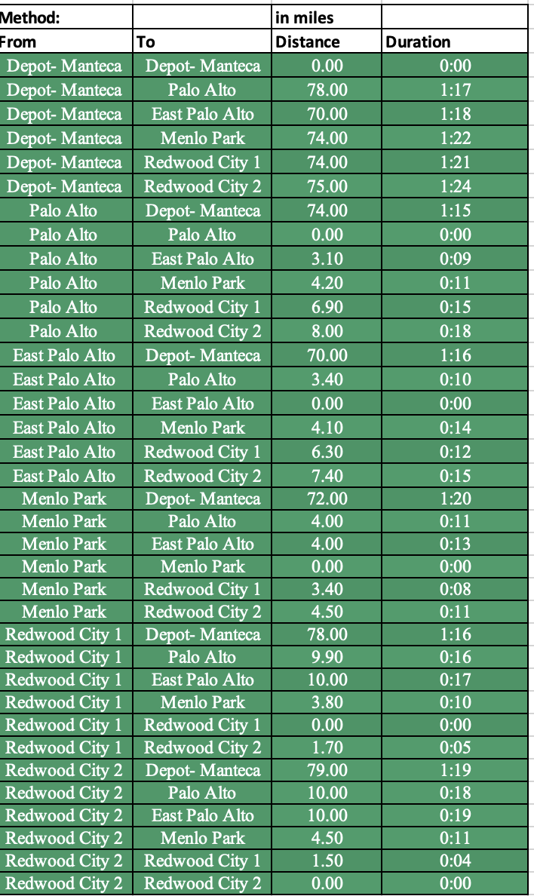

4.5.3 Vehicle Sheet Analysis
The "3.Vehicles" sheet offers a comprehensive look at the delivery fleet's characteristics and constraints, which are crucial for the solver to plan efficient routes. Key points include:
- Fleet Details: The fleet comprises vehicles (e.g., T1) starting from the Depot in Manteca, with each vehicle having specific attributes.
- Capacity Constraints: Each vehicle, such as T1, has a defined capacity (650 units), which the solver must not exceed when assigning deliveries to ensure all goods are transported efficiently and in one trip if possible.
- Cost Factors: The sheet details the fixed cost per trip for each vehicle ($797 for T1) and a variable cost per unit distance ($0.75/mile for T1). The solver uses these costs to minimize the overall distribution expense, balancing fixed and variable costs to find the most cost-effective route combinations.
- Operational Limits: Vehicles have defined operational limits, such as a maximum driving time of 9 hours and a total working time limit of 10 hours, ensuring compliance with legal and safety regulations. The solver takes these limits into account to ensure that routes are not only efficient but also feasible within operational constraints.
- Cooling Costs: The "Cooling cost / min" indicates additional costs associated with refrigeration ($0.45/min for T1), essential for maintaining the integrity of ice cream during transit. The solver considers these costs to ensure that the chosen routes are cost-efficient while maintaining product quality.
This detailed information on the fleet allows the solver to assign vehicles to routes in a way that optimizes the use of resources, adheres to capacity and operational constraints, and minimizes total distribution costs.

4.5.4 Solution Sheet Analysis
The "4.Solution" sheet presents the outcome of the solver's optimization process, detailing the routes, costs, and operational metrics for the delivery vehicles. The structure and data points include:
- Route Overview: The sheet starts with an overview of the total cost and details for each vehicle, such as vehicle "V1". This includes the number of stops, the locations served, and the sequence in which they are visited.
- Operational Metrics: For each stop, the sheet provides data such as the distance traveled, driving time, arrival and departure times, working time, profit collected, and pickup amounts. These details are crucial for understanding how the solver has optimized the route concerning time and cost efficiency.
- Cost Calculations: The sheet includes complex formulas that calculate the total cost for each vehicle's route, taking into account fixed costs per trip, cost per unit distance, and cooling costs. This ensures that the most cost-effective routes are chosen.
- Time Management: Arrival and departure times for each stop are calculated to ensure that deliveries are made within the specified time windows, optimizing the route for traffic conditions and outlet operational hours.

This detailed output from the solver demonstrates its ability to synthesize complex logistical data, including geographical locations, vehicle capabilities, and time constraints, into optimized delivery routes that minimize costs while adhering to operational constraints.
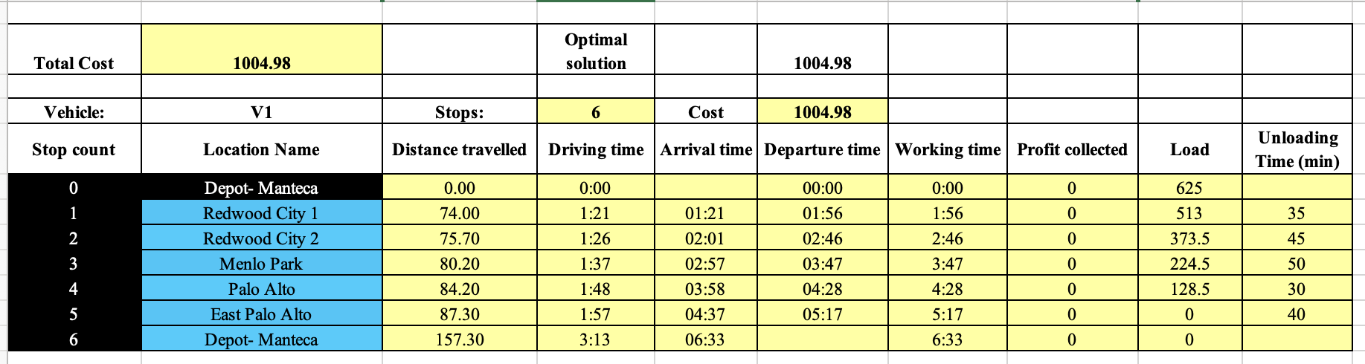
The ExcelVRP solver's application in optimizing the Baskin Robbins distribution network showcases a sophisticated approach to handling a complex VRP. By leveraging detailed data from the "1.Locations", "2.Distances", and "3.Vehicles" sheets, the solver crafts an efficient distribution strategy, as evidenced in the "4.Solution" sheet. This strategy not only reduces operational costs but also ensures timely deliveries within predefined constraints, illustrating the solver's capability in enhancing logistical operations.

4.6 Tableau: Map visualization
Tableau's map visualization feature offers a powerful tool for geographic analysis and spatial understanding. Here we are plotting data points onto interactive maps using latitude and longitude coordinates. Tableau enables users to visually explore patterns, trends, and relationships across geographical regions. We shall pinpoint locations to analyzing distribution patterns and this tool has an intuitive interface which empowers users to create dynamic maps that enhance decision-making and storytelling through data.
The following table provides details for the Latitudes and Longitudes of the 5 stores and the warehouse in Manteca.
Table 1: Data for Visual Mapping from Warehouse to all stores
S.No | Location | Latitude Origin | Longitude Origin | Latitude Destination | Longitude Destination
0 | Manteca | 37.788780 | -121.194641 | 37.480890 | -122.22773
1 | 2615 Palo Alto | 37.434170 | -122.12986 | 37.465547 | -122.2416874
2 | 1765 East Palo | 37.461130 | -122.1353 | 37.450270 | -122.18547
3 | 863 Menlo Park | 37.450270 | -122.18547 | 37.434170 | -122.12986
4 | 11501 Redwood city | 37.480890 | -122.22773 | 37.461130 | -122.1353
5 | 2 Roosevelt Redwood | 37.465547 | -122.2416874 | 37.788780 | -121.194641
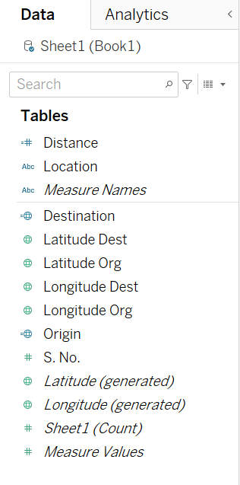
The following steps are used to provide a visualization in Tableau based on the coordinates from Table 1
- The data is stored in an Excel spreadsheet (.xls) to ensure compatibility with Tableau for mapping visualization.
- Connecting the .xls file to Tableau, the information is displayed in the Data tab as shown in Figure 1.
- It is essential to set the data in the ‘Columns’ and ‘Rows’ accurately to visualize the route in the right way as shown in Figure 2
- Tableau offers various viewing options to draw relevant information.
Figure : List of data sets created in Tableau
- In this scenario, we will map the route from Manteca to 2 Roosevelt Redwood, then to 863 Menlo Park, 1765 East Palo, 2615 Palo Alto, 11501 Redwood City, and finally back to Manteca. The map below provides a better perspective of the context.
Figure : Longitude and Latitude selection in Tableau

- Tableau creates a map visualization for the above route and provides a route as shown in Figure 3.
- The user can change the graphic used in the “Marks” tab, where in labels, details, captions, path, size of the route and colors can be modified as desired.
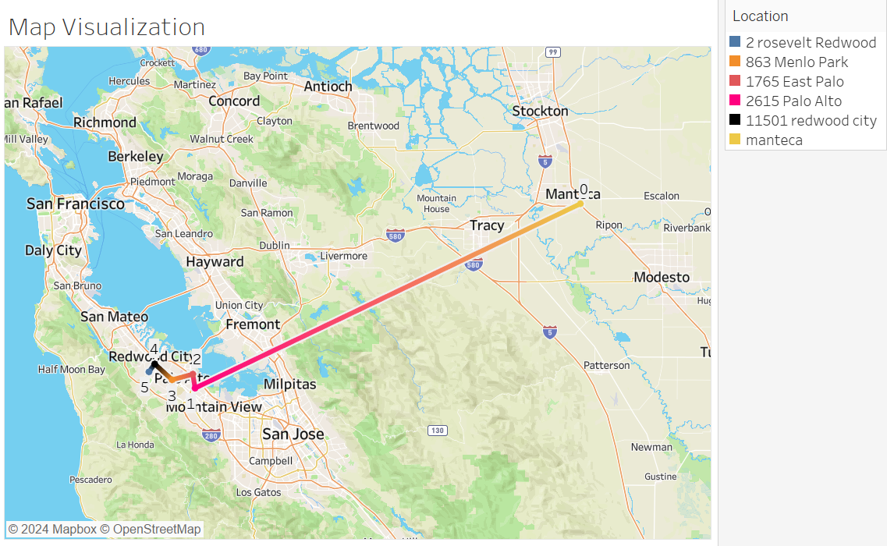
Therefore, Tableau's interactive mapping features allow users to explore data dynamically. Users can zoom in/out, pan across the map, filter data based on location, and drill down into specific regions or data points for further analysis.
Figure : Map visualization for warehouse and stores

Conclusion
In conclusion, the document delves into various aspects of the vehicle routing problem for Baskin Robbins ice-cream distribution. It covers the definition of variables, cost analysis, constraint analysis, the structure of the VRP Spreadsheet Solver. The study also discusses the application of Tableau for navigational mapping and its benefits in visualizing geographic data. Additionally, the report highlights the constraints and objectives of the research, emphasizing the focus on minimizing delivery time and cost, as well as the scalability of the proposed model for potential business expansion.

The analysis provides a comprehensive understanding of the mathematical modeling and logistical considerations involved in optimizing distribution routes for Baskin Robbins but this model is also suitable for other vehicle routing problems that involve keeping the cold chain for quality proposes. The model is built based on realistic assumptions such as time windows for arrival time, limited travel time and a potential choice for vehicle specifications .

The model also addresses few of the limitations, such as the complexity of implementation due the demand and specific time windows that help to minimize the cost caused by traffic congestion delays and the need for considering trade-offs between cost what are those trade offs, customer satisfaction, and carbon emissions. Furthermore, the section outlines the methodology used in developing algorithms to minimize delivery time and cost, while efficiently routing Baskin Robbins ice cream trucks to multiple destinations.

This is a case study that can provide practical results and an easy way to apply the basic concepts of VRP, suggesting some changes from the initial data collection where the five stores had a different day for delivery. This means that the cost may be reduced because of the length of the routes that each truck needs to cover during different days.

Overall, the analysis section offers valuable insights into the strategic utilization of advanced logistical tools for optimizing retail distribution networks and facilitating cost-efficient operational expansions. It sets the stage for further research and practical applications in the field of supply chain management and logistics.
Future Work
The methodology employed in the report for optimizing the distribution routes for Baskin Robbins ice-cream can be effectively utilized for the expansion of Baskin Robbins stores in other areas of the Bay to achieve optimized vehicle routing. By leveraging the advanced ExcelVRP solver and navigational mapping tools like Tableau, the following steps can be taken to facilitate the expansion:

Data Collection and Analysis: Gather comprehensive data on the new store locations, including addresses, geographical coordinates, and potential delivery routes. Analyze the distances between the new store locations and the central warehouse to understand the logistical requirements for the expansion.

Mathematical Modeling: Utilize mathematical modeling techniques to precisely formulate the vehicle routing problem for the new store locations. This involves defining decision variables, objective functions, and constraints specific to the expansion areas.

Application of ExcelVRP Solver: Employ the ExcelVRP solver to streamline the delivery routes for the new Baskin Robbins outlets in the expanded areas. The solver's adept application can facilitate a significant reduction in operational costs by efficiently navigating through the complex logistics, ensuring that each store is serviced within the delivery schedule.

Navigational Mapping with Tableau: Utilize Tableau as a tool to provide visual representations of the optimized vehicle routing for the expanded areas. Tableau's interactive mapping features allow for dynamic exploration of data, enabling the visualization of routes, spatial relationships, and geographic data.

Scalability Assessment: Assess the scalability of the proposed model for the expansion areas. Consider the adaptability of the ExcelVRP solver and navigational mapping tools to support strategic business expansion in new geographic locales within the Bay Area.

Future Work and Implementation: Based on the findings and insights from the methodology used in the report, develop algorithms to minimize delivery time and cost for the expanded areas. Analyze and suggest the addition of new locations in the route to maximize the utilization of resources for delivery and minimize the cost of distribution.

By following these steps and leveraging the methodology used in the report, Baskin Robbins can effectively optimize vehicle routing for the expansion of stores in other areas of the Bay, thereby enhancing operational efficiency and reducing costs in the delivery network.

7.References
1.Dávila, S., Alfaro, M., Fuertes, G., Vargas, M., & Camargo, M. (2021). Vehicle Routing Problem with Deadline and Stochastic Service Times: Case of the Ice Cream Industry in Santiago City of Chile. Mathematics, 9(21), 2750. https://doi.org/10.3390/math9212750

2.Puspitasari, H. I., Susanty, A., & Saptadi, S. (2020). Modeling the best route and truck capacity for delivering ice cream product: Vehicle routing problem approach and estimating expected interruption cost approach. AIP Conference Proceedings, 2217(1), 030048. https://doi.org/10.1063/5.0000654

3.Zhang, Y., & Chen, X.D. (2014). An optimization model for the vehicle routing problem in multi-product frozen food delivery. Journal of Applied Research and Technology, 12(2), 239-250. https://doi.org/10.1016/S1665-6423(14)72340-5

4. Toth, P., & Vigo, D. (2002). The vehicle routing problem. SIAM.

5. Ice cream refrigerated truck box - buy refrigeration truck body, ice cream refrigerated truck box product on get industry | trailerbull | the truck camper and trailer company. (n.d.). https://www.trailerbull.com/ice-cream-refrigerated-truck-box.html

6. OOIDA. (2023, November 16). Cost per mile - OOIDA. https://www.ooida.com/trucking-tools/cost-per-mile/

